Orange Early Childhood Center
 | ~ September 2019 ~
Sun | Mon |  | Tue | Wed | Thu | Fri | Sat
Parents please be sure that your child submits his/her homework assignment to the teacher – this is extremely important!!!!  On the First Day of School Please be sure to have: a crib size sheet and blanket and a complete change of clothes.  Remember only authorized people may pick up your child – check your emergency pick up list!  Family Handbook available @ www.orange.k12.nj.us/Domain/528 |  |  |  |  |  | Read “What to Expect at Preschool” or “Preschool Day Hooray” or “Rosie Goes to Preschool”  These books will help you prepare your child for school | Read “Maisy Goes to Preschool” or “First Day Jitters”  These books will help you prepare your child for school
1  Read “Ilama llama misses mama” or “The Night Before Preschool”  These books will help you prepare your child for school | 2   |  | 3 | 4 | 5  Preschool Registration 9 am-2 pm OECC 397 Park Avenue (last sign in 1 pm) | 6 | 7  Be sure that your child has a bedtime routine that you follow each day
8  Each day ask your child to tell you what he/she did at school: what areas did he play in, name a classmate, who are his teachers | 9  First Full Day of School  8:15 am to 3:20 pm  Return your Homework |  | 10 Preschool Registration  10 am-1 pm OECC 397 Park Ave  (last sign in 12:00 pm)  OBOE mtg 7:00 pm @Orange Prep Academy | 11  Return your Homework | 12  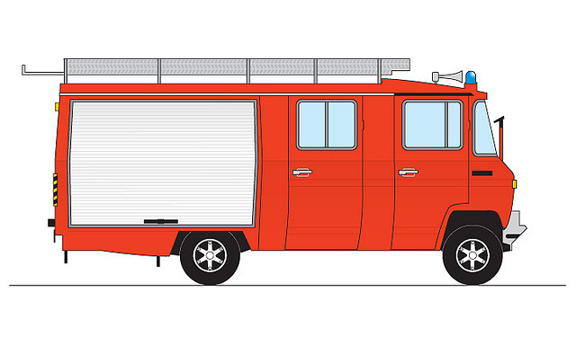  Return your Homework | 13  Return your Homework | 14  Read a story to your child before she goes to bed each night – talk about what she sees on the pages
15  Select a favorite family picture and let your child share it with his/her classmates | 16 |  | 17  Preschool Registration 10 am-1 pm OECC 397 Park Avenue (last sign in 12:00 pm) | 18    OECC 6:00 pm-8:00pm | 19 | 20  Orange High 150th Sesquicentennial  Orange High School Alumni Reception 6 pm-10 pm OHS 400 Lincoln Ave, Orange | 21  Orange Homecoming Parade 10 am-12 am  Homecoming Football Game 1:00 pm Bell Stadium
22  Begin making an “All About My School” book with your child | 23 |  | 24  Preschool Registration 10 am-1 pm OECC 397 Park Avenue (last sign in 12:00 pm) | 25 | 26 | 27  Be sure that your child has an afterschool and bedtime routine by now | 28  Finish the “All About My School” book with your child and let him/her share it with a classmate
29 |  | 30  12:30 pm Dismissal   | 6:00 pm to 8:00 pm | Cleveland 9/11  Forest 9/12  Oakwood 9/13  Heywood 9/17 | OECC 9/18  Park 9/23  Rosa Parks 9/25  Scholars 9/26 | 

